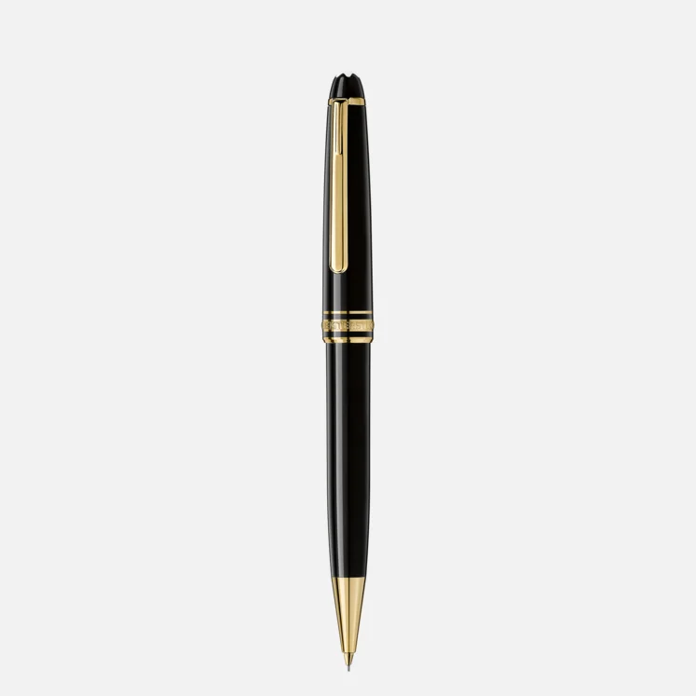

# MEISTERSTÜCK GOLD-COATED CLASSIQUE MECHANICAL PENCIL, 0.7 MM

The Meisterstück Classique in deep black precious resin with gold-coated details and surmounted by the white star emblem evolves into a distinctive design icon.

Meisterstück Gold-Coated Classique Mechanical Pencil, 0.7 mm:

Crafted with precision, the Meisterstück Gold-Coated Classique Mechanical Pencil is the epitome of writing elegance and technical finesse. This 0.7 mm pencil is a paragon of design, featuring a sleek gold-coated finish that exudes luxury. The pencil’s slim profile is balanced by its substantial weight, providing a comfortable writing experience that’s both fluid and precise. As part of the revered Meisterstück collection, this mechanical pencil stands as a testament to the legacy of quality and craftsmanship that has defined the brand for generations